NAME: G. Yashmita REG NO: 192511032

(Git/Github)

EXPERIMENT 27:

After modifying a file in a cloned repository, commit the changes

locally and push them to GitHub.

Tasks:

• Clone a repository (from question 1).

• Modify a file (e.g., README.md).

• Stage the changes with git add.

• Commit the changes with git commit -m &quot;Updated

README&quot;.

• Push the changes to GitHub using git push.

Aim
To modify a file in a cloned Git repository, stage and commit the changes locally, and push the committed changes to the remote GitHub repository.

Software Requirements
- Git
- GitHub
- Visual Studio Code
- Web Browser
- Internet Connection

Theory
Git is a distributed version control system used to track changes made to files in a project. GitHub provides a remote repository where Git projects can be stored and shared.
After modifying a file in a cloned repository, the changes are first added to the staging area using git add. The changes are then permanently recorded in the local repository using git commit. Finally, git push transfers the local commit to the remote GitHub repository.
The basic workflow is:
Modify File
↓
git add
↓
git commit
↓
git push
↓
GitHub Repository Updated

Procedure

Step 1: Clone the Repository
The repository used in the previous experiment was cloned to the local system.
git clone https://github.com/YourUsername/RepositoryName.git
Navigate to the repository directory:
cd RepositoryName
Open the project in Visual Studio Code:
code .

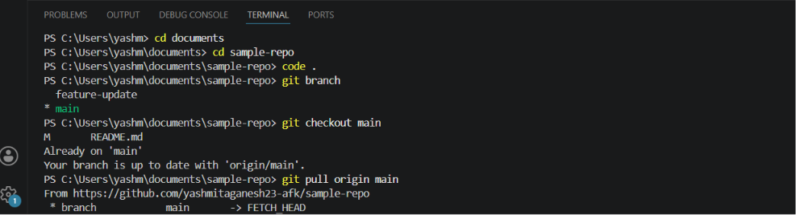

Step 2: Modify the README File
The README.md file was opened in Visual Studio Code.
A new section was added to demonstrate the modification.
For example:
## Version Control Update

This section demonstrates committing and
pushing changes to a remote GitHub repository.
The file was saved after making the changes.
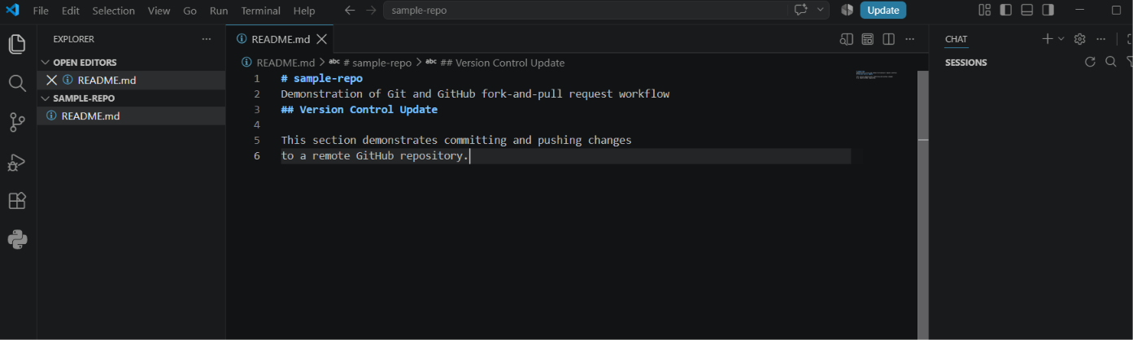

Step 3: Stage the Changes
The modified README file was added to the staging area using:
git add README.md
The status of the repository can be checked using:
git status
The modified file should appear under Changes to be committed.

Step 4: Commit the Changes
The staged changes were committed to the local repository using:
git commit -m "Updated README"
The commit was successfully created.
The output indicated:
1 file changed, 4 insertions(+)
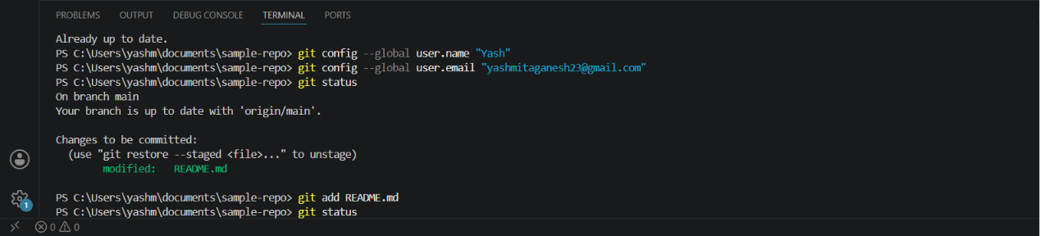

Step 5: Push the Changes to GitHub
The committed changes were pushed to the remote main branch using:
git push origin main
The push was completed successfully.
The output indicated:
main -> main
This confirms that the local main branch was successfully updated on GitHub.
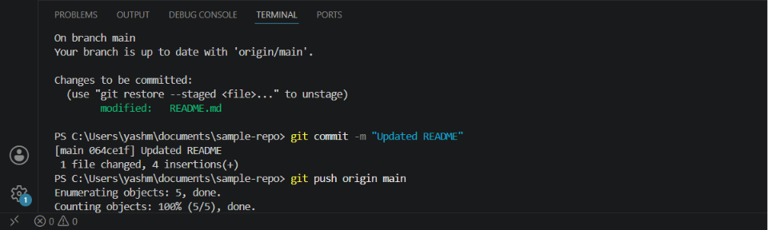
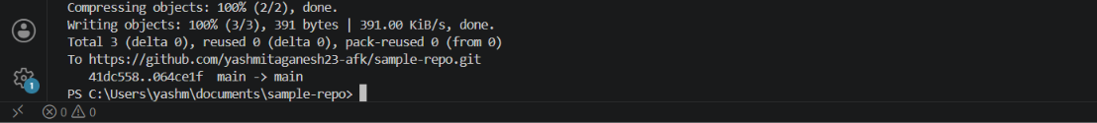

Step 6: Verify the Changes on GitHub
The GitHub repository was opened in a web browser.
The main branch was selected and the updated README.md file was opened.
The newly added content was verified to be present in the remote repository.
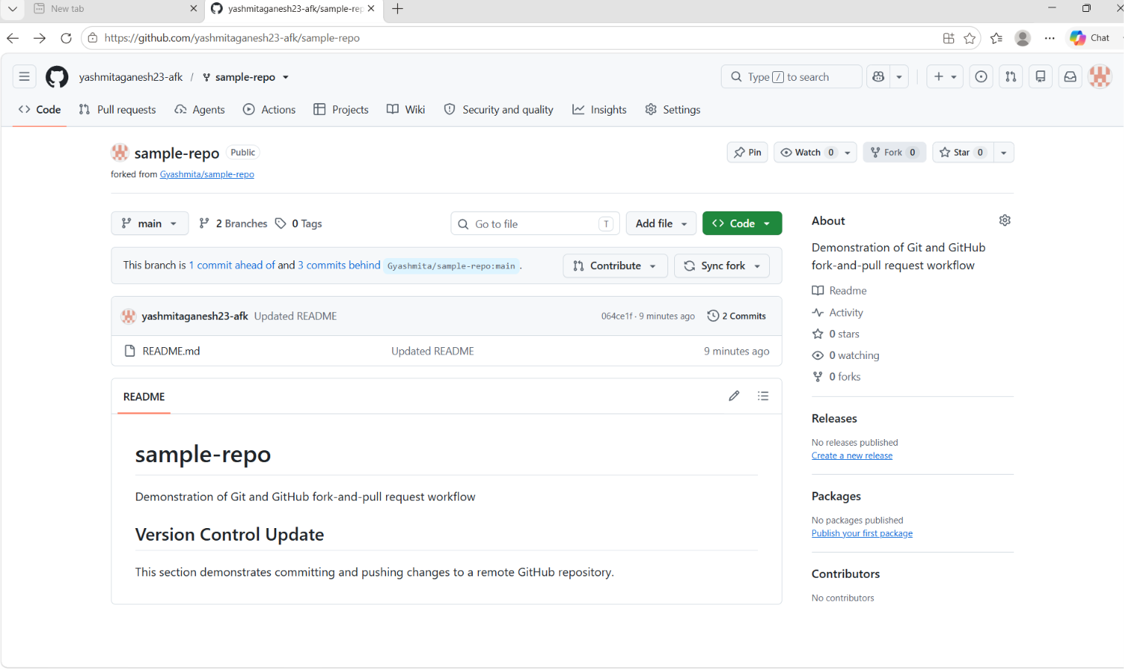

Commands Used
git clone https://github.com/YourUsername/RepositoryName.git
cd RepositoryName
code .

git add README.md
git commit -m "Updated README"
git push origin main

Result
The modified README.md file was successfully staged, committed locally, and pushed to the GitHub repository using Git. The changes were verified successfully in the remote repository.

